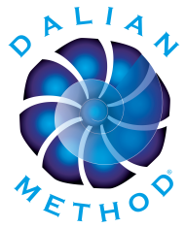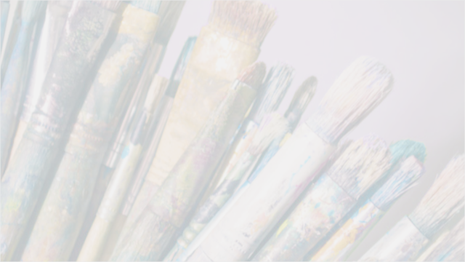­

COMMUNICATE with YOUR HEART:

A Workshop on the BEAUTY of VULNERABILITY

**What is Process Art?**

Process Art is a way of painting relying on intuition. The purpose is not about creating a product to hang or sell but rather about the experience and self-discovery. Relating to our own creative instinct in this way opens up insight and aliveness. It can also be a powerful active meditation in that it allows us to see how our mind interferes. How we experience this process reflects how we live our life and can be a vehicle for healing.

In this workshop use Process Art to:

* Explore the Beauty of Your Vulnerability
* Express your Unique Creativity
* Practice Trusting Your Intuition
* Practice Letting Go of the Outcome
* Connect with Messages from Your Heart

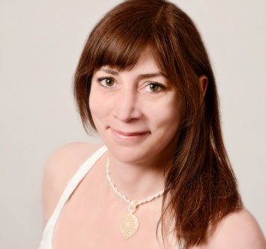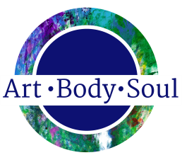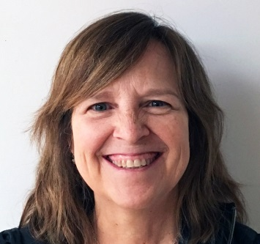

**Facilitators**

**Workshop Information**

*Combining two Powerful Approaches: Process Art & The Dalian Method™*

During this workshop we will paint using the techniques of process art to take a journey inward. Along the way there may be an encounter with fear, discouragement, sadness, or anger. Likewise creating can also be experienced as joy, delight, and peace.  
  
Feelings emerge during the process because they exist within us and have been repressed in our energy field and subconscious. Everything we’ve pushed down, because we didn’t want to say or feel it, is held within our bodies and affects our well-being.

As we clear burdensome thoughts and emotions with the Dalian Method we come closer to our hearts.

**Workshop Schedule**  
Check website, variations occur  
  
Friday 7:00-9:00pm  
*Introductions and discussion / Dalian Method Find Answers to Your Questions*   
Saturday 9:30am-5:30pm  
*Process Art Session / 72 Minute Dalian Method*  
Sunday 10:30am – 1:00pm  
*Process Art Session / Closing Meditation*  
  
*No artistic ability or experience with painting or the Dalian Method required.*

The owner of Expanding Consciousness in Kansas City, Leela was inspired to become a facilitator because of what the Dalian Method did to heal her childhood trauma, depression, and anxiety.   
Read more about Leela at www.leelaharis.com/about-leela

**What is The Dalian Method™?**

The Dalian Method created by Mada Dalian is a healing modality that utilizes the breath and out loud verbal expression. It’s a powerful, ground-breaking guided process that permanently releases trapped emotions and transforms limiting beliefs.

​In this workshop use the Dalian Method to:

* Go Within for Answers to Your Questions
* Accept All of Your Emotions & Thoughts
* Learn How to Transform Negativity into Love & Compassion
* Honor Your Truth
* Release and Transform Repressed Anger, Sadness, Resentment, & Insecurity to Enhance Communication with the Heart

**Leela Haris**  
 Kansas City

**Madeleine Newkirk**Memphis

A native Memphian and Owner of Art•Body•Soul Madeleine is a facilitator for both the Dalian Method and Painting Out Loud, a process art experience.   
Read more about Madeleine at   
[www.artbodysoulstudio.com/meet-madeleine](https://www.artbodysoulstudio.com/meet-madeleine.html)

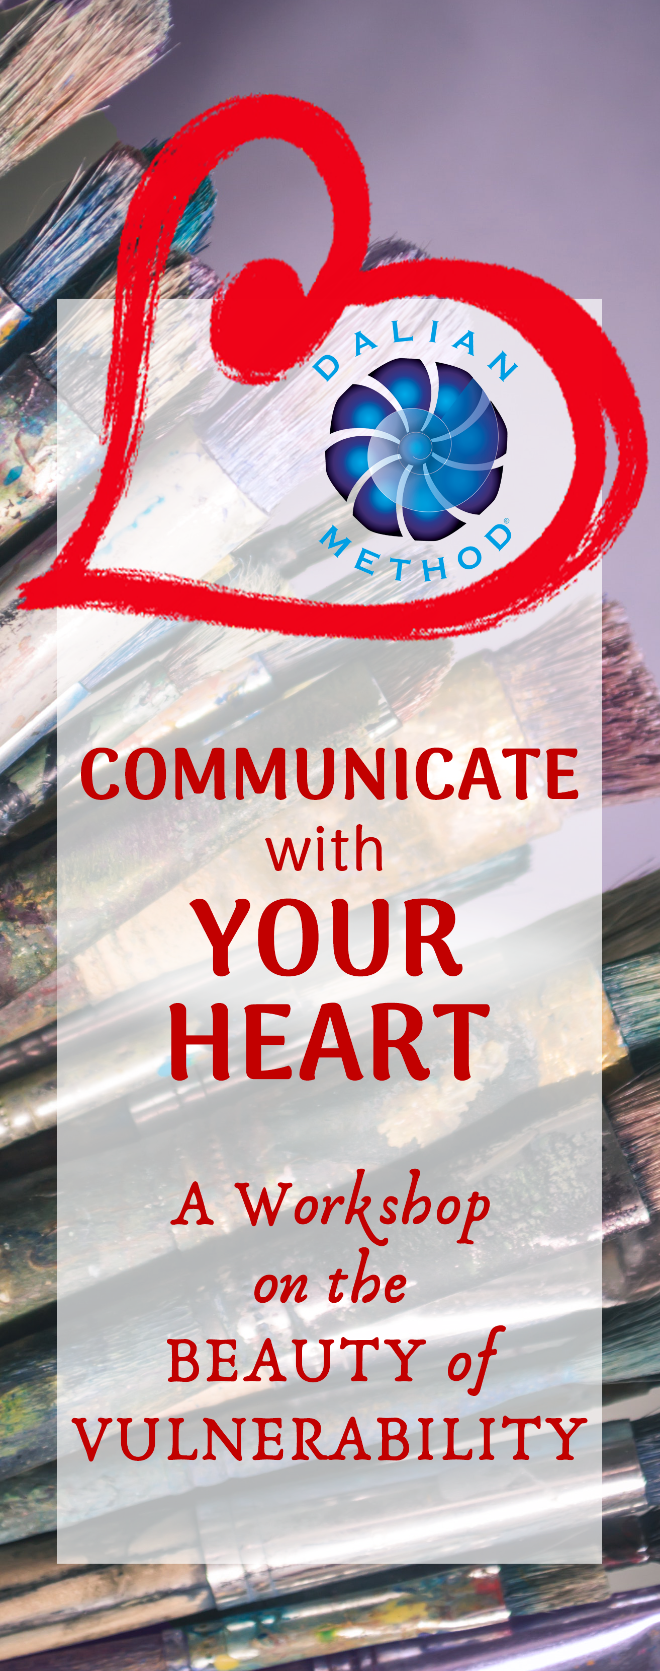

1024 S Yates Rd  
Memphis TN 38119

**WORKSHOP   
REGISTRATION**

Go to   
https://www.artbodysoulstudio.com/  
communicate-with-your-heart.html   
to see a current list of cities and dates and to register.

Don’t see your city and would like us to come to you or would like to host a COMMUNICATE with YOUR HEART workshop?

Contact us at  
[info@artbodysoulstudio.com](mailto:info@artbodysoulstudio.com)

**PRIVATE DALIAN METHOD HEALING SESSIONS**

If you can’t make a workshop or prefer one-on-one work, you can schedule an online private   
Dalian Method   
Session with   
Madeleine   
or Leela

Madeleine: Info@ArtBodySoulStudio.com  
Leela: Leela@LeelaHaris.com

